Experiment **2**  
 Sequential Synthesis and FPGA Device

Programming

# Verilog code

Kamyar Rahmani - Mohammad Mashreghi

810199422 - 810199492

1. 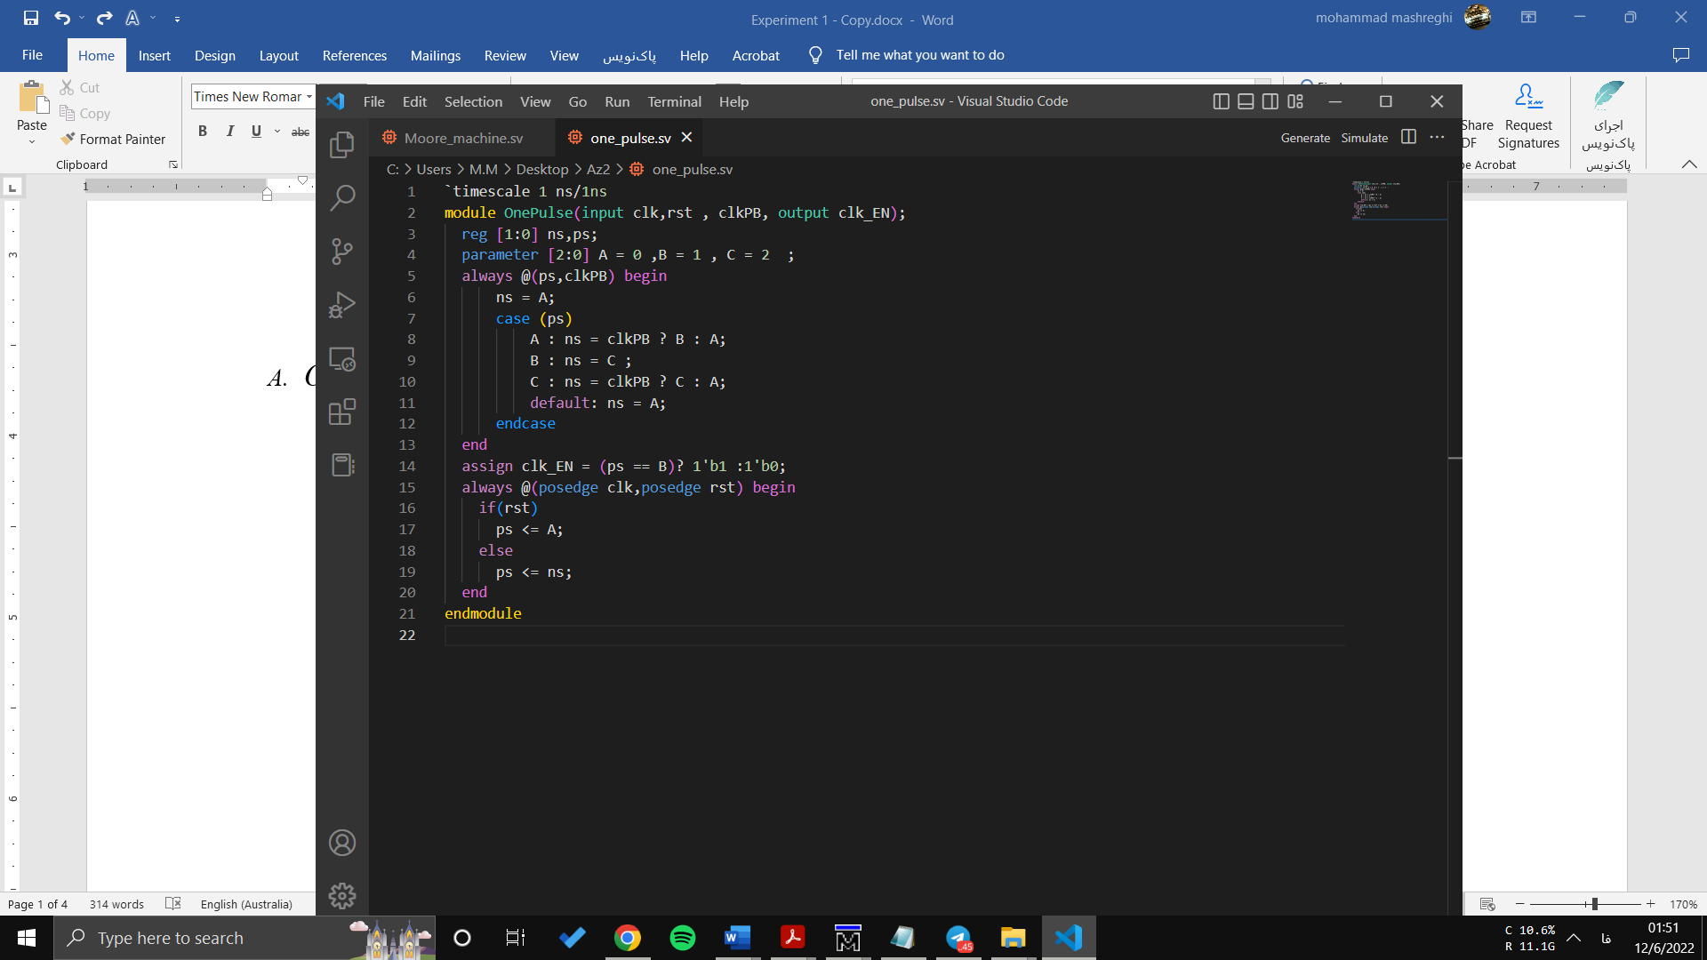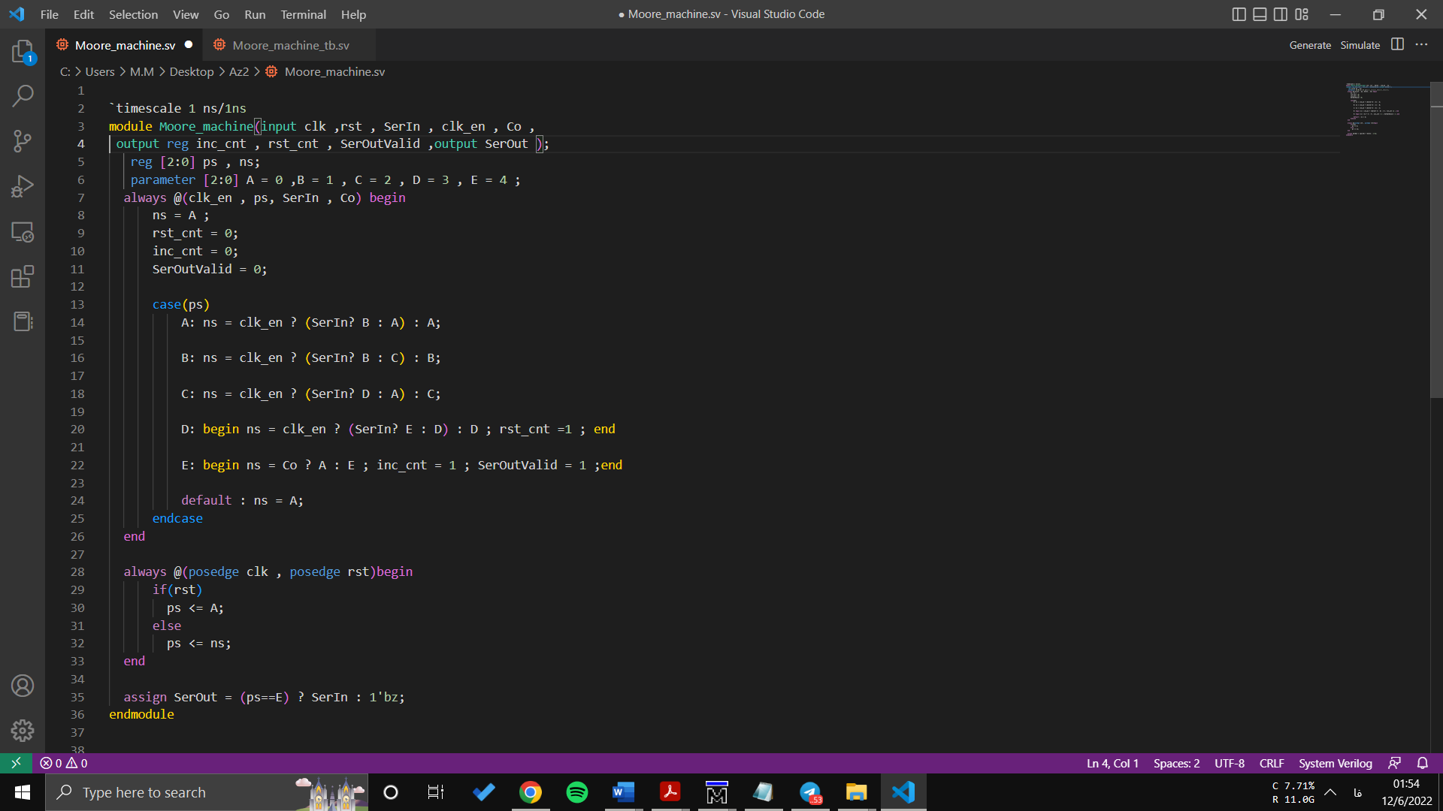Onepulser
2. 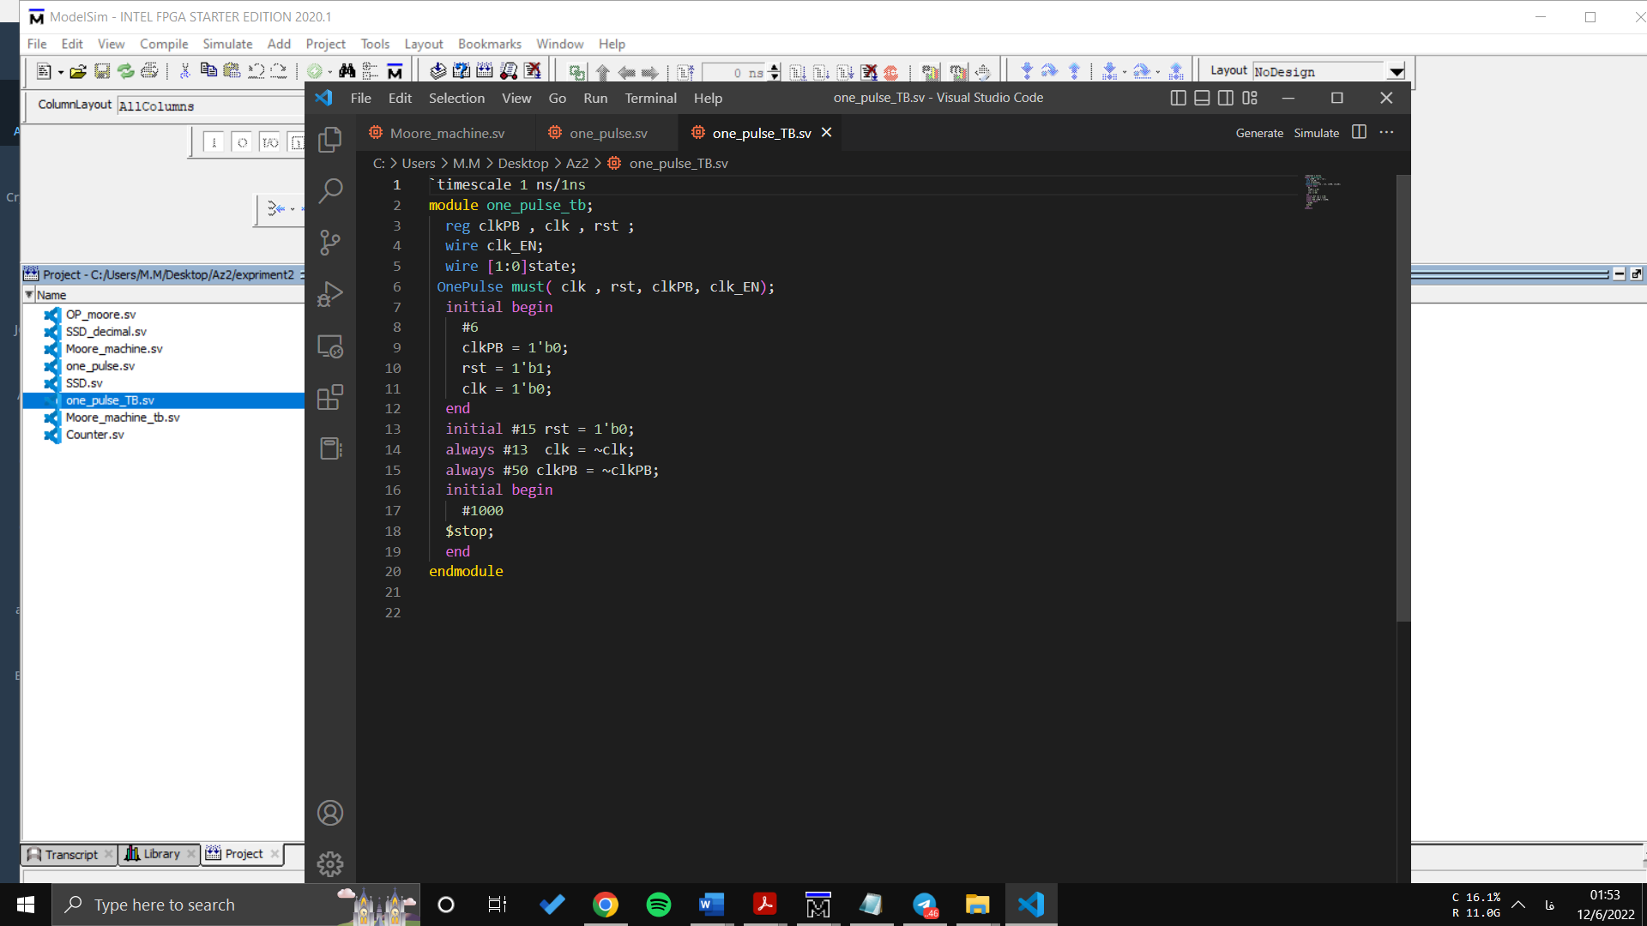Onepulse-Testbench

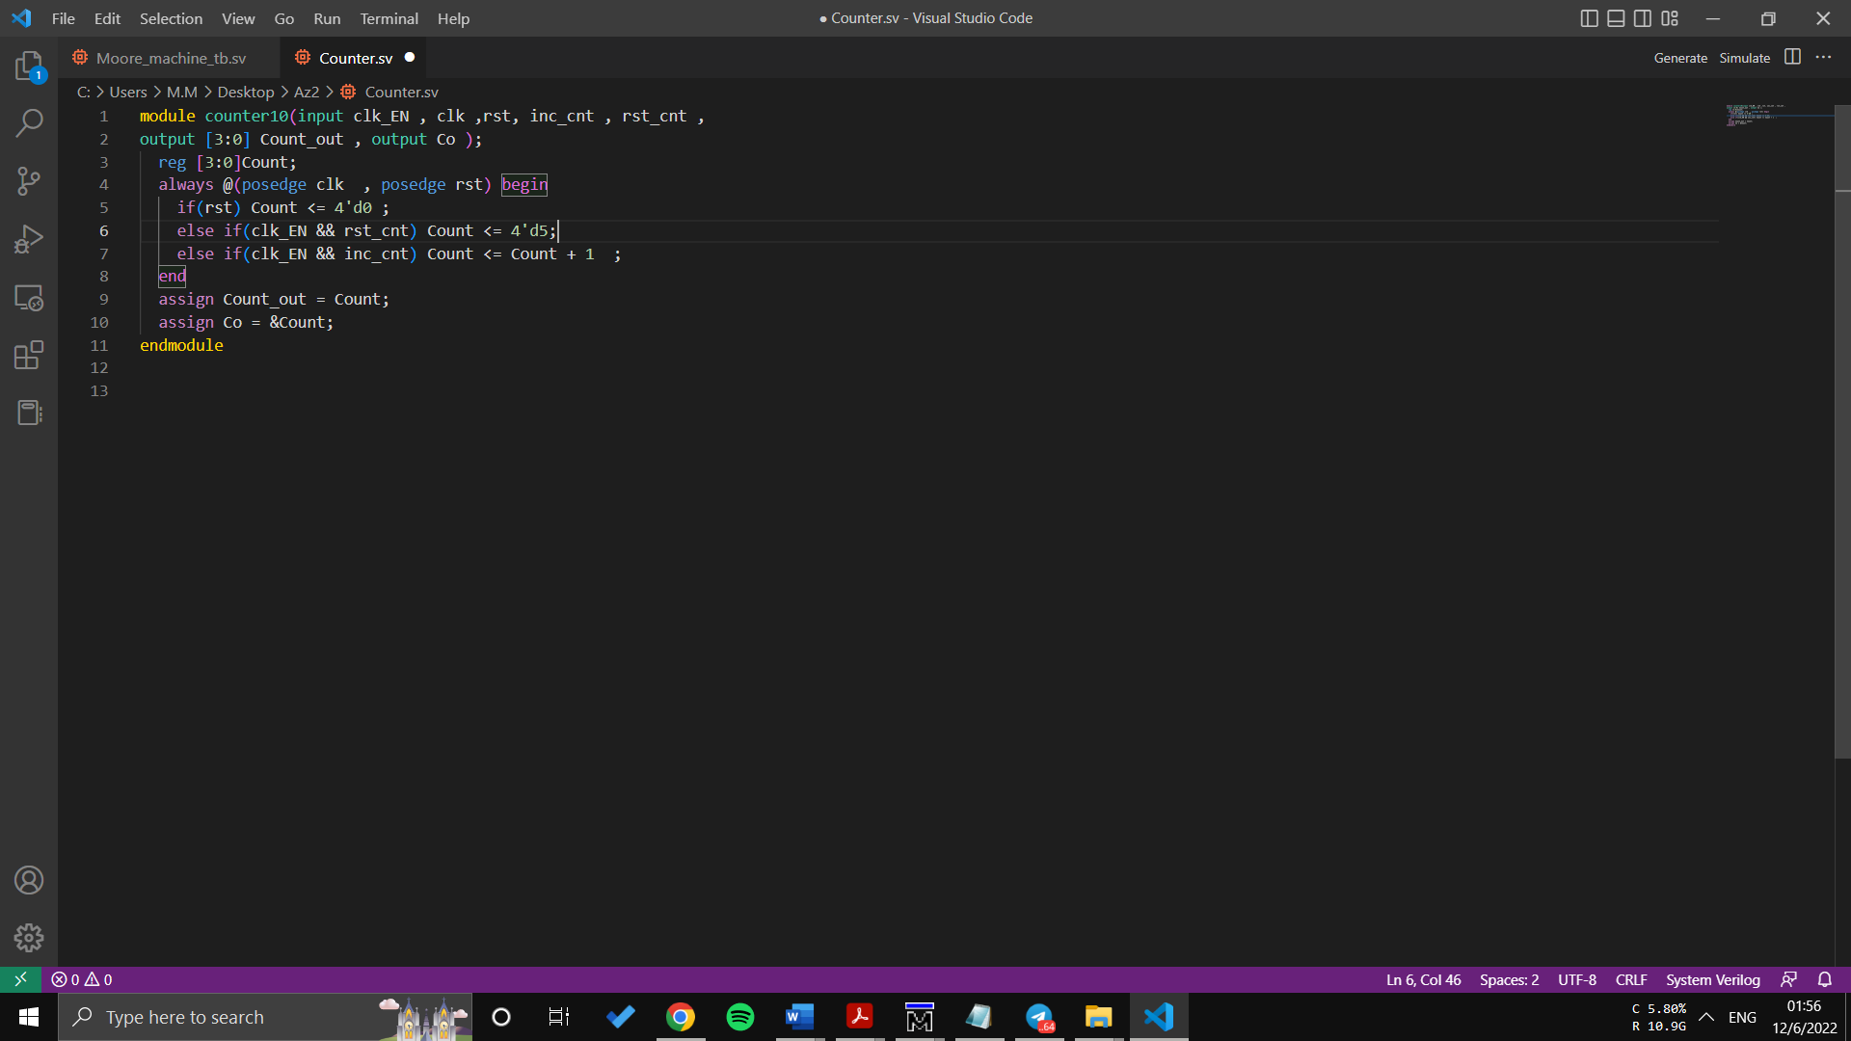

1. Moore_Machine
2. Counter
3. Onepulser

1. 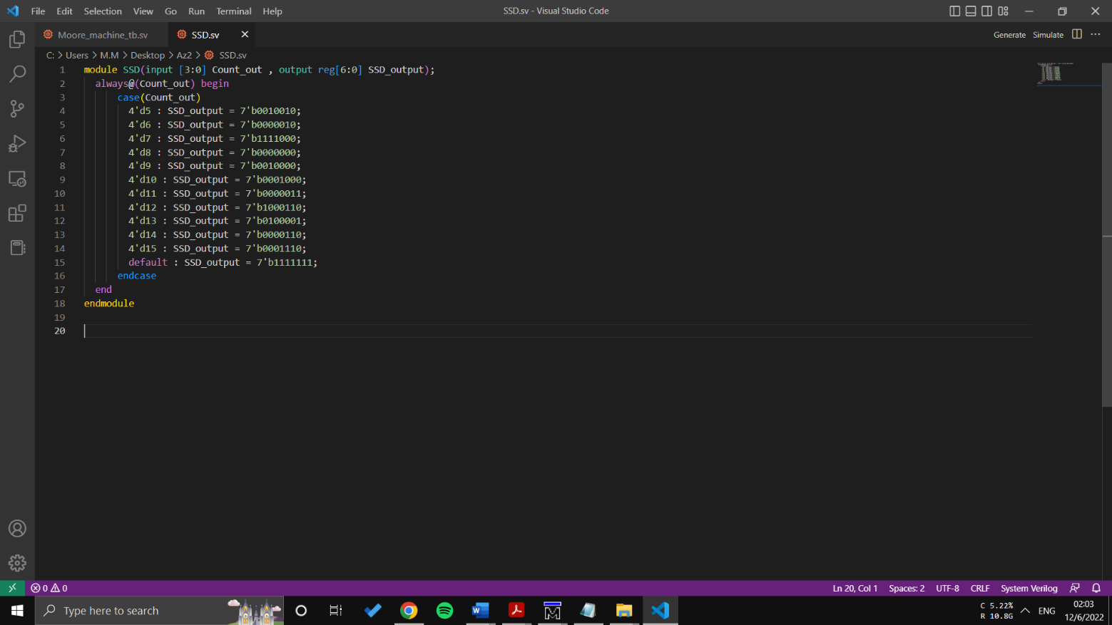SSD
2. Serial transmitter

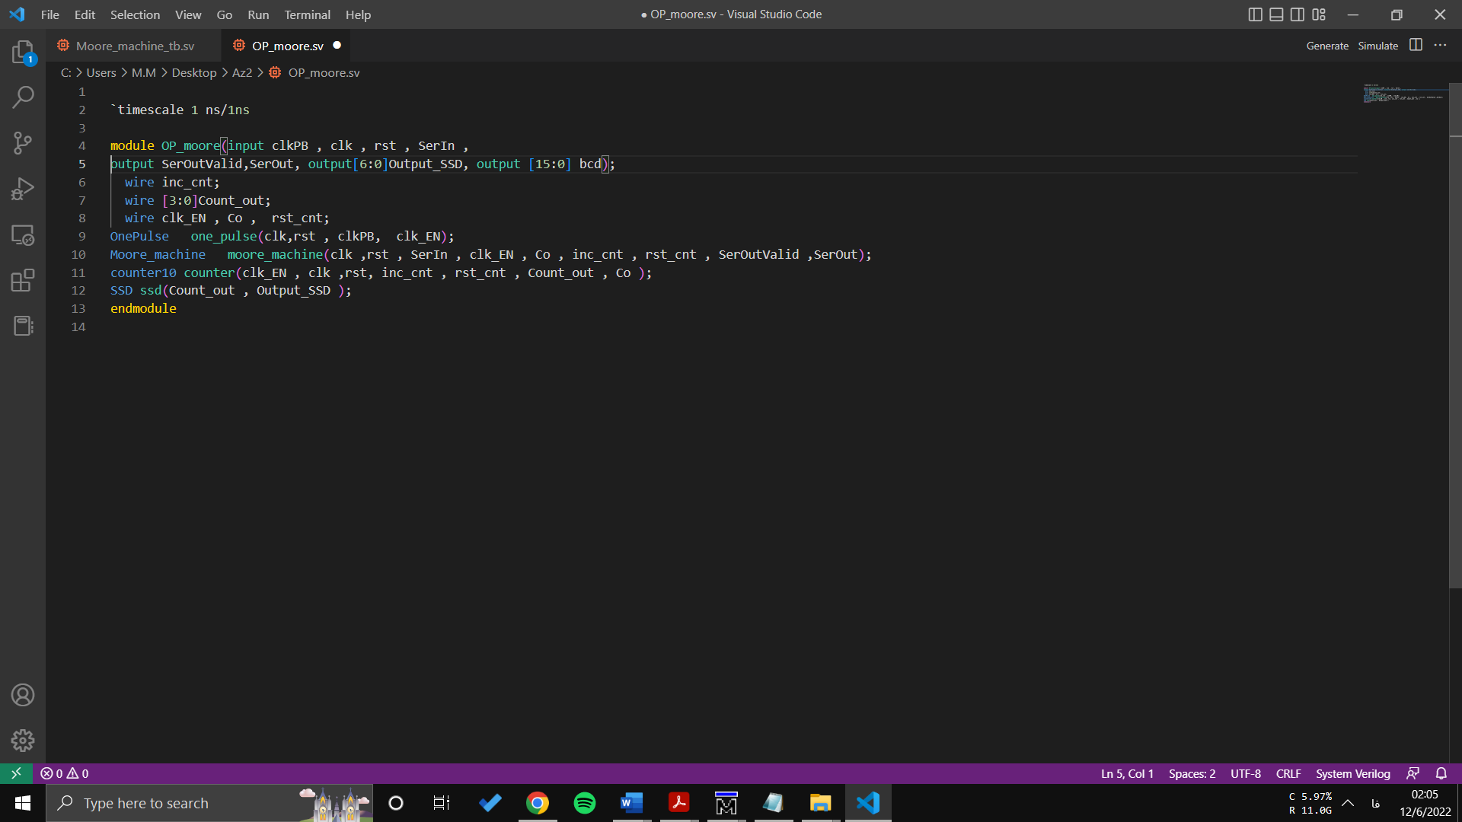

1. Serial transmitter - Testbench

